**PROJECT REPORT**

1. **Project Title: Financial Performance Report Dashboard (2013-14)**

**Course: Business Analyst Intern**

**Date: 15.07.2025**

1. **Acknowledgement:**

I would like to thank everyone who supported and guided me during this project. Their help made it possible to complete this work successfully.

1. **Abstract**:

The project is about creating a Power BI dashboard to analyze financial performance across different countries, products, and time periods, using key financial metrics such as sales, profit, cost of goods sold (COGS), and discounts using different charts, KPIs, Slicers and Table Matrix.

|  |  |  |
| --- | --- | --- |
| SN | Contents | Page No. |
|  | Introduction | 04 |
|  | Objectives | 04 |
|  | Tools and Technologies | 04 |
|  | Methodology | 05 |
|  | Analysis and Findings | 08 |
|  | Implementation | 14 |
|  | Conclusions | 15 |
|  | Future Scope | 16 |

1. **Table of Contents:**
2. **Introduction:**

This report outlines the creation and implementation of a **Financial Performance Dashboard** using Microsoft Power BI. The dashboard is designed to consolidate and visualize financial data from multiple sources, providing a clear and interactive representation of an organization’s financial status. Through a range of visual elements such as charts, graphs, and KPI indicators, the dashboard presents essential financial metrics including revenue, expenses, profitability, and cash flow.

By leveraging Power BI’s data transformation and visualization tools, the dashboard enables efficient analysis and real-time monitoring of financial performance. It enhances data transparency, supports financial reporting, and simplifies the interpretation of complex datasets for users at all levels of the organization.

1. **Objectives:**

The primary objective of this project is to transform raw financial data into a dynamic, interactive dashboard that enables stakeholders to monitor and evaluate an organization’s financial health in real time. By integrating key performance indicators (KPIs) such as revenue, expenses, net profit, gross margin, and cash flow, the dashboard offers a comprehensive view of financial trends, variances, and business outcomes.

1. **Tools and Technlogies:**

The project was developed using **Microsoft Power BI Desktop** for data modeling, visualization, and report creation. **Power Query** and **DAX (Data Analysis Expressions)** were used for data transformation, calculations, and KPI development.

1. **Methodology:**

The development of the Financial Performance Dashboard using Microsoft Power BI followed a structured and iterative process to ensure accuracy, usability, and effective data visualization. The methodology can be outlined in the following key phases:

1. **Data Preparation & Setup:**

**Import and understand the dataset.**

Connect to the dataset, ensure all columns are in appropriate data types, and correct any anomalies.

**● Steps:**

* 1. Import the dataset into Power BI.
  2. Click on model view to make relations and after that click on transform data to inspect each column and ensure correct data types (dates, numerical values, categorical data).
  3. Identify missing values and handle them (e.g., imputation, exclusion).
  4. Perform initial inspection and understand unique values in categorical columns (e.g., Segment, Country).
  5. Click on Load data to upload all the data on DATA pane.

1. **Creating New Measures**:

**● Steps:**

1. Go to Modeling Tab and click on Add Measure
2. Measures: Total Revenue, Profit Margin
3. Total Revenue:
4. Profit Margin:



1. **Dashboard Creation:**

**● Steps:**

1. Go to the Visualization pane and take Card(new) and from the data pane drag (one by one) Total Revenue, Sum of Profit and avg unit sold and drop to the visualization pane to get the report.
2. Again, go to the visualization pane, take Table and from the data pane drag these columns to visualization pane to get the report.

1. A screenshot of a computer

   AI-generated content may be incorrect.Again, go to the visualization pane, take Line Chart and from the data pane drag these columns to visualization pane to get the report.
2. go to the visualization pane, take Donut Chart and from the data pane drag these columns to visualization pane to get the report.

1. go to the visualization pane, take Stacked Bar Chart and from the data pane drag these columns to visualization pane to get the report.

1. Again, go to the visualization pane, take Slicer and from the data pane drag these columns to visualization pane. Then, on Data pane click on Date Hierarchy and select year and drop it to the visualization pane.

1. **Analysis & Findings:**
   1. **A white rectangular sign with black text

      AI-generated content may be incorrect.**

* **127M — Total_Revenue**  
  This indicates that the business has generated a total revenue of **127 million** over the selected period. This is the **gross income** from all sales before any costs or deductions.
* **17M — Sum of Profit**  
  This shows the **total profit earned**, which is **17 million**. It represents the **net income** after subtracting costs and expenses from the total revenue.
* **1.61K — Average of Units Sold**  
  This metric shows the **average number of units sold**, which is **1,610 units** (1.61K). It gives insight into the average sales volume, useful for analyzing performance and operational efficiency.

* **Sales Trend:**

1. The chart shows **monthly fluctuations** in total sales throughout the year.
2. Sales started at **6.6M in January**, rose slightly in February (**7.3M**), then dropped in March (**5.5M**).
3. A **steady increase** can be seen from April to June, peaking at **9.5M** in June.
4. A dip follows in July (**7.7M**) and August (**5.9M**).
5. **September to October** sees a **sharp rise**, peaking at **21.7M in October** — the **highest sales month**.
6. Sales decline in November (**12.7M**) and recover to **17.1M in December**.

* **Visual Elements:**
* The **line chart** with data points shows the exact monthly values.
* The **filled yellow area** under the line emphasizes the volume of sales visually over time.

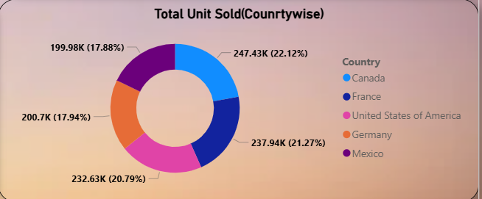

* The image shows a **Donut Chart** titled **"Total Unit Sold (Countrywise)"**, and it's used to represent the **distribution of total units sold across different countries**.
* **Chart Description: Total Unit Sold (Countrywise)**
* **Legend (Color-coded):**  
  Each color represents a different country:
  + **Canada** — 247.43K units (22.12%)
  + **France** — 237.94K units (21.27%)
  + **United States of America** — 232.63K units (20.79%)
  + **Germany** — 200.7K units (17.94%)
  + **Mexico** — 199.98K units (17.88%)
* **Values:**  
  The values on the chart indicate the **total number of units sold per country** along with their **percentage share of the total sales volume**.
* **Insights and Observations:**
* **Canada** had the highest units sold, contributing **22.12%** of the total.
* **France** and the **USA** follow closely with **21.27%** and **20.79%**, respectively.
* **Germany** and **Mexico** contributed nearly equal portions, each accounting for roughly **18%** of the total.
* The distribution is fairly **balanced across all five countries**, with no single country dominating the sales volume.
  1. 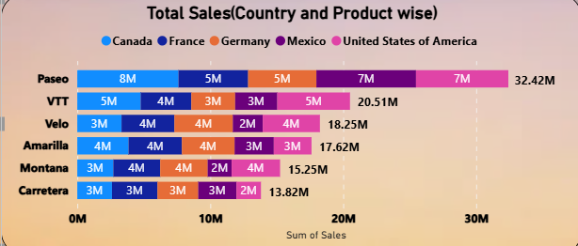

The image shows a **100% Stacked Bar Chart** titled **"Total Sales (Country and Product wise)"**, which compares the **sum of sales** for different **products** across **countries**.

* **Chart Description:**
* **Y-Axis (Vertical):**  
  Represents **Product categories**:
  + Paseo
  + VTT
  + Velo
  + Amarilla
  + Montana
  + Carretera
* **X-Axis (Horizontal):**  
  Represents the **Sum of Sales** in millions (M), ranging up to 35M.
* **Legend (Color-Coded):**  
  Indicates **Countries**:
  + Canada
  + France
  + Germany
  + Mexico
  + United States of America
* **Key Insights:**

1. **Paseo** is the top-performing product with total sales of **32.42M**, contributed mainly by:
   * Canada: 8M
   * USA: 7M
   * Mexico: 7M
   * France and Germany: 5M each
2. **VTT** ranks second with **20.51M** in total sales, led by:
   * Canada: 5M
   * USA: 5M
   * Mexico: 5M
   * France and Germany: 3M each
3. **Carretera** has the lowest total sales at **13.82M**, with even distribution among countries.
4. Most products have **diverse contributions** from all five countries, showing balanced market presence.
   1. 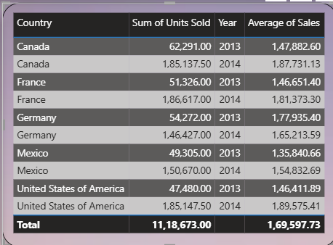

The image shows a **summary data table** from a Power BI dashboard displaying **country-wise performance metrics for the years 2013 and 2014**. The table includes columns for **Country**, **Sum of Units Sold**, **Year**, and **Average of Sales**.

* **Key Observations:**

1. **Total Units Sold (across all countries and years):**  
   **11,18,673 units**
2. **Overall Average Sales Value:**  
   **₹1,69,597.73**
3. **Top Performers:**
   * **Canada (2014):** Highest units sold (1,85,137.50) and high average sales (₹1,87,731.13).
   * **United States of America (2014):** Strong average sales (₹1,89,575.41).
   * **France and Germany (2014):** Both show increased average sales compared to 2013.
4. **Growth Trend (2013 to 2014):**
   * All countries show an **increase in units sold** and **average sales** from 2013 to 2014.
   * Indicates positive financial and operational performance year-over-year.
   1. A screenshot of a computer

      AI-generated content may be incorrect.

The image shows a **Power BI slicer** that is **based on the "Year" level** of a **Date Hierarchy**.

* **Slicer Description:**
* **Type:** Vertical List Slicer
* **Field Used:** Date (from a date hierarchy)
* **Displayed Level:** **Year**
* **Values Available:**
  + **2013**
  + **2014**
* **Functionality:**
* This slicer allows users to **filter the entire dashboard or report visuals** based on the **selected year**.
* When a user selects:
  + **2013**, only data from the year 2013 will be displayed across visuals.
  + **2014**, only data from 2014 will be shown.
  + Selecting both includes data from **both years**.
* **Purpose of This Slicer:**
* Enables **year-wise analysis** of sales, units sold, revenue, and other metrics.
* Helps in **comparing performance across different years**.
* Useful for **drilling down or slicing the data** by a time-based filter without editing visuals.

**F. Implementation:**

The implementation of the Financial Performance Dashboard using Power BI involved the integration of financial and sales data across multiple dimensions, time, geography, and product category. The goal was to build a centralized, interactive platform that enables dynamic analysis of key financial metrics for the years 2013 and 2014.

**G. Conclusion:**

The Power BI Financial Performance Dashboard successfully consolidates and visualizes key financial data from 2013 and 2014, offering clear insights into revenue, profit, sales trends, and regional performance. By combining interactive visualizations such as KPIs, line charts, donut charts, and bar graphs, the dashboard enables users to quickly interpret complex datasets and monitor business performance in real time.

The implementation of filters, slicers, and year-wise comparisons has enhanced the dashboard's analytical capabilities, allowing decision-makers to assess growth patterns, identify high-performing products and markets, and make data-driven strategic decisions. The intuitive layout and dynamic nature of the dashboard have improved both accessibility and usability for finance teams and executives.

* + 1. **Future Scope:**

To enhance the dashboard’s utility and scalability, several improvements can be considered in future phases:

1. **Multi-Year Analysis:**  
   Extend the dashboard to include data beyond 2014 to track long-term performance and growth trends.
2. **Forecasting & Predictive Analytics:**  
   Integrate time series forecasting models to predict future sales, revenue, and profitability using Power BI's AI capabilities or Python/R scripts.
3. **Expense and Cost Analysis:**  
   Incorporate detailed cost components and expense breakdowns to assess net profit margins more comprehensively.
4. **Drill-Through Functionality:**  
   Add drill-through pages to enable users to explore transaction-level data for deeper insights into specific products, regions, or months.
5. **Mobile Optimization:**  
   Adapt the dashboard layout for mobile and tablet views, enabling real-time access on-the-go for executives.
6. **Integration with Live Data Sources:**  
   Connect the dashboard to live databases or cloud-based accounting systems (e.g., SAP, QuickBooks) for automated, real-time updates.
7. **User Role-Based Views:**  
   Implement row-level security to provide customized views for different users based on their roles (e.g., finance managers, regional heads, executives).